**Warkworth Santa Parade 2025**

**Saturday 13 December**

**11am start**

**Santa Parade Participation Registration Form**

To participate in the Warkworth Santa Parade please complete this form.

**Email completed form to** [**murray@onemahurangi.co.nz**](mailto:murray@onemahurangi.co.nz) **or deliver it to the Warkworth Information Centre, 1 Baxter Street, Warkworth by Thursday 5th December.**

We would like to participate by providing (please circle):

* parade entry
* demonstration/performance
* kids’ entertainment (describe, and include whether this will be pre-, during or post-parade)
* sponsorship (describe)
* other (describe)

|  |  |
| --- | --- |
| Name of group/organisation: |  |
| Address: |  |
| Contact person: |  |
| Phone: |  |
| Email: |  |

**Parade Entrants Only**

**\*\* Please complete all sections in this form to assist us with our planning**

|  |  |
| --- | --- |
| Name of your parade entry: |  |
| Brief description of parade entry: |  |
| Parade mode of transport: | ** |
| On foot /Car / ute without trailer |  |
| Truck /Car / ute with trailer |  |
| Truck and Trailer |  |
| Other (describe) |  |
| No. of vehicles: | ** |
| No. of people taking part: |  |
| Float length (incl towing vehicle): | ** |
| Do you require use of a truck, towing vehicle in order to enter a float? | ** |

**THANK YOU FOR YOUR PARTICIPATION – WE LOOK FORWARD TO SEEING YOU**

**2025 Warkworth Santa Parade**

**Saturday 13 December – 11.00am**

**Proudly sponsored by**





Calling all local businesses, community groups, schools

(With awesome PTAs) and local kindergartens

It’s time to get the tinsel out, design an awesome float and get amongst the Warkworth Santa Parade!

**Register your float in the Warkworth Santa Parade!!**

**All are welcome!**

We’re expecting over 3000 people to attend this increasingly popular community event. Don’t miss your opportunity to connect with your local community and the people who support you. Register your group and/or organisation today for the Santa Parade!

Does your shop, business, community group, sports club or school have a fun idea for a float or child-friendly entertainment before, during or after the parade? – we would love to have you participate.

The more floats and entertainment we have, the more friends, families and visitors there will be lining the streets of Warkworth, and the more you will get noticed. And the real bonus is - it’s fun!

**PRIZES FOR BEST ENTRIES**

Thank you to our sponsors who once again have provided fabulous prizes for the best float in each of the following categories:

* Bridgehouse - best business float
* Natures’ Nest - best educational institution float
* Keith Hay Homes - best community group float
* Hunting & Fishing - People’s Choice Award

**JUDGING CRITERIA**

There will be 3 incognito judges, evaluating your float at secret locations before and during the parade.

**PRIZEGIVING FESTIVITIES**

The prizes will be awarded in Lucy Moore Park at the end of Baxter Street at the conclusion of the parade. There will also be an opportunity for the kids to have their photo taken with Santa at this time.

Prize giving will commence at approximately 12.30pm so please make sure you have a representative from your float in attendance in case you win a prize. Prizegiving will conclude at approx. **1.00pm.**

**SPONSORSHIP & ASSISTANCE**

If you can assist in any way, either as a sponsor or helper, please fill in the form on the registration page. Our team are accepting funds to sponsor some of the paid entertainment; etc, for which we will thank you in the Mahurangi Matters.

We are also looking for any main street retailers who are willing to offer the use of footpath space outside their shops for use by fundraising stalls. Again, please advise us on the form on the registration page.

**TIMETABLE OF EVENTS:**

**9.30pm – 10:00am** Floats to arrive and park along Baxter Street ready for parade start

**10.30am - 10.45am** Float Safety check by parade officials

**10.30am** Float participants can view other floats in the parade (Santa will make an appearance)

**10.45am** All participants must be returned to their float ready for parade start

**11.00am** Starting from Baxter Street, Queen Street, Loop around Bayleys Building back onto Queen Street, down Kapanui Street, up Wharf Street, Around roundabout - TWO LOOPS, with the second loop ending at Baxter Street.

**FINAL LOOP:** Baxter Street, Queen Street, Loop around Bayleys Building onto Queen Street, down Kapanui Street, up Wharf Street and left to Baxter Street where participants can disembark from floats. Floats can depart via either Neville Street or Percy Street. Everyone is invited to walk along to Lucy Moore Park in Baxter Street for the Parade Prizegiving which will be approximately 45minutes). Carols in the Park will take place from 8pm and we invite you all to attend this annual event as well.

**11:45pm – 12.00pm** Parade ends – all floats remaining for prizegiving to park at Baxter Street. All floats leaving immediately afterwards can exit town via either Percy St or Neville Street however the far end of Baxter Street will remain closed. All welcome to walk back for prizegiving and spot prizes. Please see map below.

**12.00pm** In Baxter Street for photos with Santa, prize-giving and lolly scramble.

**1.00 pm approx.** Santa Parade Festivities conclude. Live Music will be playing on the stage later in the evening, prior to Carols in the Park.

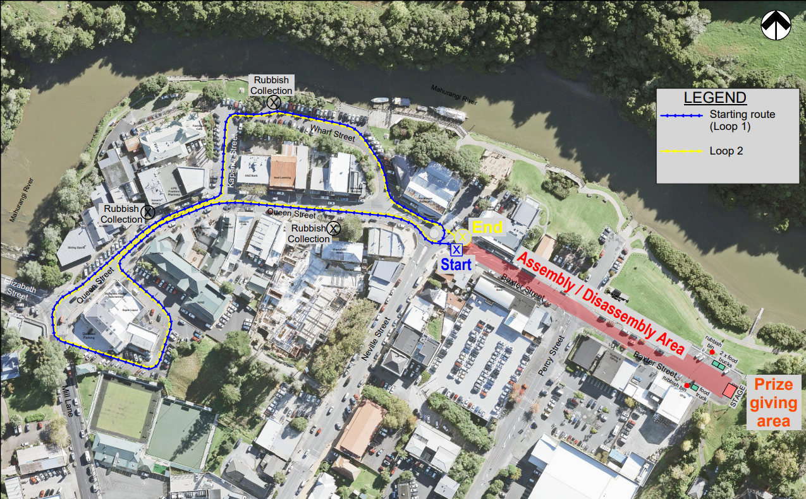 **Parade Route** :

**Final Loop**:

*Parade ends at the Neville Street roundabout. Park your float and disembark passengers on Baxter Street then head up on foot to the Baxter Street Reserve for prize giving, family fun day and Carols in the Park.*

**So, come on, sign up today and join us for an afternoon and evening of fun and festivities!**

**RULES FOR FLOAT ENTRIES**

* Event Manager’s instructions must be adhered to at all times - if the Event Manager feels your float is unsafe or disorderly, you may be asked to forfeit your involvement for the safety of other participants.
* **Lollies or any giveaway items are NOT to be thrown from floats** - any items you wish to gift to the crowd must be passed out by hand from street level to discourage the crowd from entering the road space.
* Organisers of floats with small children must ensure children are secure on the float and there are enough parents to assist. It is preferable to have walkers alongside the float in case of emergency and it would ease the load on our marshals if each float can provide walkers.
* Organisers of floats with small children must ensure they provide adequate protection from the weather (sunscreen, shade or umbrellas etc) and plenty of water.
* Parade entrants with animals are responsible for collecting and responsibly disposing of any animal defecation. They must also ensure they have adequate water/shade where required and manage any reactions to loud noises (all care will be taken to place animal groups away from known noisy floats).
* Float drivers are to ensure they keep a safe following distance between floats in case the one in front must stop suddenly. Speed is to be kept at a slow walking pace.
* Please encourage your float drivers to play Xmas-themed music from their stereo systems to enhance the atmosphere for the crowd. Encourage the participants to shout and wave –There are spot prizes on the day
* It is suggested that floats are parked up along Baxter Street as far as Percy Street. The far end of Baxter Street will be closed off for the Carols in the Park, however Percy Street will be accessible after the parade finishes. There will be NO traffic management in this area so please ensure you take utmost care when unloading your participants and walking along to the prize-giving.
* In the event we have to cancel due to inclement weather, announcements will be made on More FM and will be posted on onemahurangi.co.nz the Facebook pages of One Mahurangi Business Association (@onemahurangi) and local community Facebook group pages. There is no alternative rain date.
* Most importantly – HAVE HEAPS OF FUN!

**onemahurangi.co.nz**