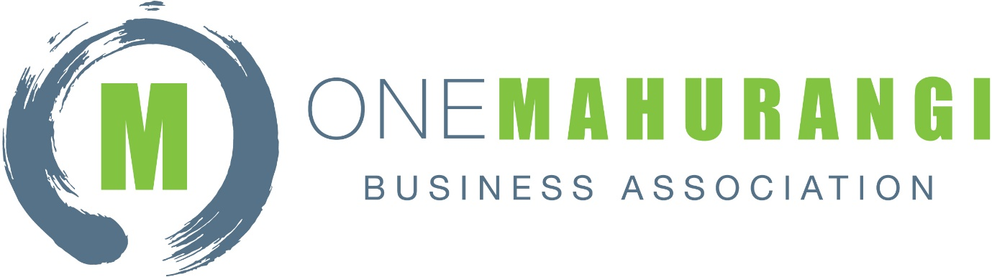

Proxy Voting Form

I, ________________________________________________ as a member or representative of business __________________________________________, which is a current Associate or BID Affiliate Member of the One Mahurangi Business Association, hereby appoint _____________________________ of One Mahurangi Business Association as my proxy to vote on my behalf at the Annual General Meeting of the One Mahurangi Business Association to be held on Wednesday, 27th September 2023 at the Bridgehouse Tavern in Warkworth.

Signature_______________________________________________________________________

Dated__________________________________________________________________________

